**4.2 POWER SUPPLY CIRCUIT**

Power supply is a reference to a source of electrical power. A device or system that supplies electrical or other types of energy to an output load or group of loads is called a power supply unit or PSU. In this project, a +5 V DC regulated power supply is derived from the power supply unit designed and implemented. The Figure shows the circuit diagram designed to get the +5 V DC regulated power supply for the project. A full-wave rectifier is a device that has two or more diodes arranged so that load current flows in the same direction during each half cycle of the ac supply.

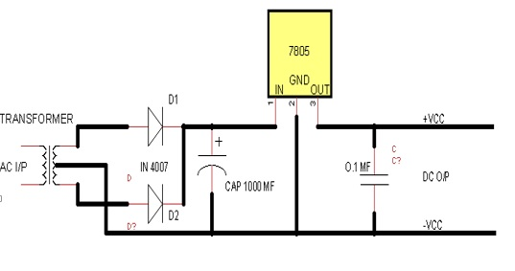

**Figure 4.2.1 Power supply Circuit**

We need to rectify AC power to obtain the full use of both half-cycles of the sine wave, a different rectifier circuit configuration must be used. Such a circuit is called a full-wave rectifier. One kind of full-wave rectifier, called the center-tap design, uses a transformer with a center-tapped secondary winding and two diodes, as in Figure above.

**The power supply unit mainly consists of the following**

* **STEP DOWN TRANSFORMER**

When AC is applied to the primary winding of the power transformer it can either be stepped down or up depending on the value of DC needed. In our circuit the transformer of 230v/12-0-12v is used to perform the step down operation where 230 V AC appears as 12 V AC across the secondary winding. The top of the transformer is positive and the bottom is negative. The current rating of the transformer used in our project is 0.5 A. Apart from stepping down the AC voltage; it gives isolation between the power source and electronic circuitries.

* **RECTIFIER UNIT**

This circuit's operation is easily understood one half-cycle at a time. Consider the first half-cycle, when the source voltage polarity is positive (+) on top and negative (-) on bottom. At this time, only the top diode is conducting; the bottom diode is blocking current, and the load “sees” the first half of the sine wave, positive on top and negative on bottom. Only the top half of the transformer's secondary winding carries current during this half-cycle as in Figure.

* **FULL-WAVE CENTER-TAP RECTIFIER**

Top half of secondary winding conducts during positive half-cycle of input, delivering positive half-cycle to load. During the next half-cycle, the AC polarity reverses. Now, the other diode and the other half of the transformer's secondary winding carry current while the portions of the circuit formerly carrying current during the last half-cycle sit idle. The load still “sees” half of a sine wave, of the same polarity as before: positive on top and negative on bottom.

* **FILTERING UNIT**

Filter circuits which are usually capacitors, acting as a surge arrester, always follow the rectifier unit. This capacitor is also called as a decoupling capacitor or a bypassing capacitor, is used not only to ‘short’ the ripple with frequency of 120Hz to ground but also to leave the frequency of the DC to appear at the output.

* **VOLTAGE REGULATORS**

The voltage regulators play an important role in any power supply unit. The primary purpose of a regulator is to aid the rectifier and filter circuit in providing a constant DC voltage to the device. Power supplies without regulators have an inherent problem of Changing DC voltage values due to variations in the load or due to fluctuations in the AC liner voltage. With a regulator connected to the DC output, the voltage can be maintained within a close tolerant region of the desired output. IC7805 is used in this project for providing +5v DC regulated supply.

* **FEATURES**

• Output Current up to 1A

• Output Voltages of 5, 6, 8, 9, 10, 12, 15, 18, 24V

• Thermal Overload Protection

• Short Circuit Protection

• Output Transistor Safe Operating Area Protection